Extended Abstract Template:
How to write a two-page extended abstract for ReSIST 2024
A. Author^{1*}, B. Author², and C. Author³
¹Affiliation of the Author, City, Country
²Affiliation of the Author, City, Country
³Affiliation of the Author, City, Country
*Corresponding author: email

Abstract— This guide aims to assist authors in formatting their extended abstracts using Microsoft Word for publication in the program and proceedings of Regional Symposium on Science and Technology (ReSIST) 2024. Authors are kindly requested to adhere to the guidelines outlined in this document when preparing their extended abstracts. In addition to serving as a comprehensive template, this document provides detailed instructions to help authors conveniently input or paste their own text. It is recommended that the word count for the abstract (this section) does not exceed 200 words.

- INTRODUCTION
To obtain an electronic copy of this template, please visit the conference website at https://ReSIST.um.ac.ir/. If you have any inquiries, feel free to contact the conference organizers.
Please use Times New Roman font and single spacing for all text. Kindly follow the formatting guidelines provided below:

Title: 16-point bold
Authors: 10-point
Affiliation: Italicized 10-point.
Abstract: 10-point

The main body of the text should be in 12-point, with a 0.4 cm indentation before the first line of each paragraph. The text should be justified to occupy the full line width and avoid ragged right margins.
Headlines should be 14-point, formatted in upper case letters and numbered. There should be a 9 pts space before the headline and a 3 pts space after the headline.
- PAGE LAYOUT
The symposium paper should be no longer than two pages. Make sure your paper adheres to the A4 page size, which is 21 cm wide and 29.7 cm long. Set all margins, including top, bottom, left, and right, to 2 cm. Arrange the main text of your paper in a two-column layout.
Avoid making any changes to the header or footer of the document. Page numbers will be added later on.
- PAGE STYLE
All paragraphs should be justified, both left-justified and right-justified.

A. Abbreviations:
Define abbreviations the first time they are used in the text.

B. Units:
Please use the International System of Units (SI) or the Centimeter-Gram-Second (CGS) system as primary units
Include a leading zero before decimal points: "0.25" instead of ".25."

C. Equations:
The recommended font options for typing equations are either Times New Roman or Symbol. It is also acceptable to insert equations as graphics.
Number equations consecutively, with equation numbers placed within parentheses and right-aligned using a right tab stop, e.g., Eq. (1).
a  b    
Use the abbreviation “Eq. (1),” even at the beginning of a sentence.

D. Figures and Tables
Figures, preferably with a resolution of 300 dpi, and tables should be centered within the column. In the case of large figures and tables, they can span across both columns. However, if a table or figure occupies more than one column width, it should be positioned either at the top or bottom of the page. Captions for figures should be placed below them, while table headings should appear above the tables. Figures and tables should be inserted into the document after they have been cited in the text. When referring to a figure, use the abbreviation "Fig. 1" even when it appears at the beginning of a sentence. Please use 10-point Times New Roman font for figure captions and table headings.

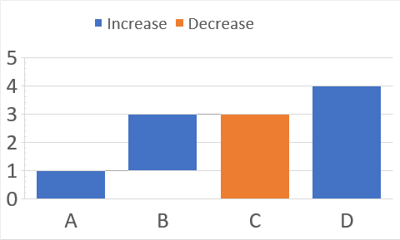
Fig. 1 Example of a figure caption

To style a table, please refer to Table 1.

Table 1. Extended Abstract Sections
Sectionª | Content
1. | Introduction
2. | Methodology
3.  4. | Results  Discussion
5. | Conclusion
6. | References
^{a,}This is a suggested structure for organizing the sections and can be customized.

H. References
To cite a reference in the text, use brackets such as [1], [2], and number them sequentially. Avoid using phrases like "Ref. [3]" or "reference [3]" unless it is at the beginning of a sentence. For instance, when starting a sentence, you can write, "Reference [3] was..."
ACKNOWLEDGMENT
The heading of the Acknowledgment section and the References section should not be numbered.
REFERENCES
- Author, A., & Author, B. (Year). Title of article. Title of Journal, volume number (issue number), page range. https://doi.org/10.0000/0000
- Authors, A. (Year). Book title: Subtitle. (Edition) [if other than the 1st]. Publisher.
- Author, A. (Year). Title of dissertation or thesis, Doctoral dissertation or Master’s thesis, Name of Institution Awarding Degree.
- Author, A., Author, B., & Author, C. (Year, Month Day–Day). Paper title. Conference Name, City, Country. URL

